Database Solutions for Café Administration

**Group Members**

**Sharanya Akkone** sakkone5074@sdsu.edu

**Shravani Hariprasad** shariprasad3296@sdsu.edu

**Jiatong Xu** jxu4719@sdsu.edu

**Thanishya Yella** tyella1673@sdsu.edu

**San Diego State University**

**Course**

MIS686 Enterprise Database Management

**Instructor**

Dr. Morteza Safaei-Pour

**Abstract**

# The culmination of our academic exploration in the Enterprise Database Management course is encapsulated in a term project that meticulously applies theoretical concepts to real-world contexts. This initiative entails a comprehensive understanding of course material, leading to the design and implementation of an intricate yet practical cafe management system. Far from a mere academic exercise, this venture delves into the nuanced realm of database management systems, emphasizing their indispensable role in optimizing and streamlining essential business operations within the unique parameters of a cafe environment. Through this project, we scrutinized the complexities of inventory management, customer interactions, staff organization, and operational efficiency, underscoring the vital significance of robust database management in ensuring the seamless functioning and success of a modern-day cafe establishment.

# 

# Topic Selection

## 1.1 Selected Topic and Domain

Our group has selected to design and implement a cafe management system for our term project. This decision was informed by a detailed analysis of potential applications and a unanimous recognition of the team's collective expertise and interest in the hospitality sector. The system is envisioned as a comprehensive solution to streamline operations within a cafe, from inventory management to customer service and employee scheduling. Our group's diverse background, which includes part-time employment in cafes, internships in hospitality management, and academic projects in related fields, provided us with a solid foundation and a unique perspective on the challenges faced by the industry.

## 1.2 Introduction

The cafe management system is aimed at addressing common operational inefficiencies in cafes, such as inventory discrepancies, customer wait times, and the manual handling of orders and payments. By automating these processes, our system will enhance the customer experience, improve the accuracy of inventory and sales data, and allow cafe owners and managers to focus on business growth and customer engagement. Our system will not only manage day-to-day operations but also provide valuable insights through data analytics, enabling informed decision-making.

## 

## 1.3 Advantages and Contributions

The cafe management system presents several advantages that underscore its value proposition. Firstly, it simplifies the complexity of managing inventory by automating stock levels and reordering processes, thereby reducing waste and saving costs. Secondly, it enhances the customer experience through a faster ordering system and personalized service, leading to increased customer satisfaction and retention. Thirdly, it provides a centralized platform for managing staff schedules, payroll, and performance, leading to improved staff management and efficiency. These advantages are significant contributions to the operational management of a cafe, offering a competitive edge in a bustling market.

## 

## 1.4 Use Cases

Our cafe management system is versatile and can be adapted to various settings within the hospitality industry. It is suitable for small local cafes, large chain coffee shops, and even restaurants seeking to improve their operational efficiency. The system can be tailored to different business models and is scalable to accommodate business growth. Use cases extend beyond the point-of-sale to include inventory management for suppliers, staff management for human resources, and customer relationship management for marketing teams. Our system is a multi-faceted tool designed to optimize operations across all levels of the cafe business.

# 

# Conceptual Data Modeling and Database Design

## 2.1 List of Business Rules

In designing our cafe management system, we established a set of business rules that guided the structure and relationships within our database:

**Customers:**

Each customer is uniquely identified by a Customer_ID.

Customers have a name, email, phone number, and loyalty points.

There is no limit on the loyalty points that a customer can accumulate.

**Orders:**

Each order is uniquely identified by an Order_ID.

Every order is linked to a customer via Customer_ID.

Orders record the date they were placed (Order_Date), the total amount, and the status of the order.

Each order is also linked to a staff member via Staff_ID.

**Order Items:**

Each item within an order is uniquely identified by an Order_Item_ID.

Order items link back to their respective orders via Order_ID.

Each order item references an item from the menu through Item_ID.

The quantity of each menu item in an order is recorded.

**Menu Items:**

Each menu item is uniquely identified by a Menu_Item_ID.

Menu items are described by name, type, price, and an optional description.

Each menu item is linked to an ingredient through Ingredient_ID.

**Order Promotions:**

Each application of a promotion to an order is uniquely identified by an Order_Promotion_ID.

The promotion application links to both the Order_ID and Promotion_ID.

**Promotions:**

Each promotion is uniquely identified by a Promotion_ID.

Promotions include a name, description, start date, end date, and the amount of discount provided.

**Staff:**

Each staff member is uniquely identified by a Staff_ID.

Staff are described by name and role type.

Staff may have additional attributes such as coffee skills level, register management skills, management experience, and leadership skills.

**Ingredients:**

Each ingredient is uniquely identified by an Ingredient_ID.

Ingredients have a name and a category.

**Inventory:**

The inventory is tied to ingredients via Ingredient_ID.

The quantity of each ingredient in the inventory is tracked.

**Customer Reviews:**

Each review is uniquely identified by a Review_ID.

Reviews are linked to customers via Customer_ID.

Each review includes the text of the review, a rating, and the date the review was submitted.

## 2.2 Conceptual Data Modeling: ER/EER Diagram

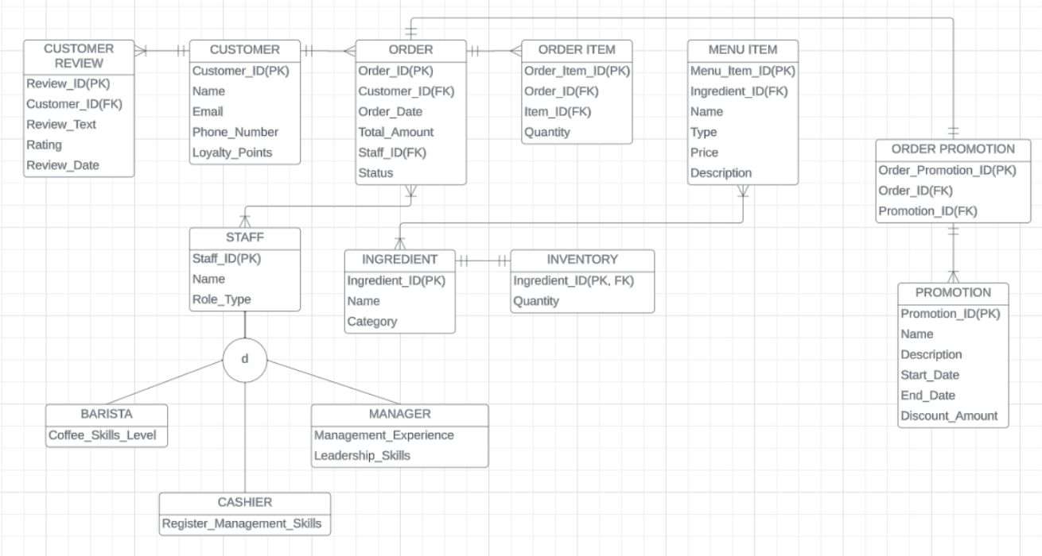

**Entities and Attributes:**

**Customer**

Attributes: Customer_ID (PK), Name, Email, Phone_Number, Loyalty_Points

**Order**

Attributes: Order_ID (PK), Customer_ID (FK to Customer), Order_Date, Total_Amount, Staff_ID (FK to Staff), Status

**Order_Item**

Attributes: Order_Item_ID (PK), Order_ID (FK to Order), Item_ID (FK to Menu_Item), Quantity

**Menu_Item**

Attributes: Menu_Item_ID (PK), Ingredient_ID (FK to Ingredient), Name, Type, Price, Description

**Order_Promotion**

Attributes: Order_Promotion_ID (PK), Order_ID (FK to Order), Promotion_ID (FK to Promotion)

**Promotion**

There are a total of 6 promotions throughout the year.

Attributes: Promotion_ID (PK), Name, Description, Start_Date, End_Date, Discount_Amount

**Staff**

Attributes: Staff_ID (PK), Name, Role_Type, Coffee_Skills_Level (nullable), Register_Management_Skills (nullable), Management_Experience (nullable), Leadership_Skills (nullable)

**Ingredient**

Attributes: Ingredient_ID (PK), Name, Category

**Inventory**

Attributes: Ingredient_ID (FK to Ingredient), Quantity

**Customer_Review**

Attributes: Review_ID (PK), Customer_ID (FK to Customer), Review_Text, Rating, Review_Date

**Cardinalities:**

**Customer to Order**

One-to-Many: A customer can have zero, one, or many orders.

**Order to Order_Item**

One-to-Many: An order can contain one or many order items.

**Menu_Item to Order_Item**

One-to-Many: A menu item can be part of zero, one, or many order items (assuming a menu item can be ordered multiple times).

**Order to Order_Promotion**

One-to-Many: An order can have zero, one, or many associated order promotions.

**Promotion to Order_Promotion**

One-to-Many: A promotion can be applied to zero, one, or many orders.

**Staff to Order**

One-to-Many: A staff member can handle zero, one, or many orders.

**Ingredient to Menu_Item**

One-to-Many: An ingredient can be used in zero, one, or many menu items.

**Ingredient to Inventory**

One-to-One: Each ingredient has one corresponding inventory record.

**Customer to Customer_Review**

One-to-Many: A customer can have zero, one, or many reviews.

**Associative Entities:**

Order_Promotion

Links the Order and Promotion tables in a many-to-many relationship.

Contains Order_ID and Promotion_ID as foreign keys.

Has its own primary key Order_Promotion_ID.

This associative entity allows for the realization that an order can have multiple promotions applied to it, and a single promotion can be applied to multiple orders. The Order_Promotion_ID serves as a unique identifier for each association between an order and a promotion, thereby resolving the many-to-many relationship into two one-to-many relationships.

**Subtype/Supertype:**

**Staff**

It's implied that there could be subtypes of staff such as Barista, Cashier, and Manager, each with their own specific attributes.

Super-type: Staff with attributes common to all staff members.

Sub-types:

Barista: Specialized with Coffee_Skills_Level.

Cashier: Specialized with Register_Management_Skills.

Manager: Specialized with Management_Experience and Leadership_Skills.

## 2.3 Transformation of ER/EER Model to Relational Model:

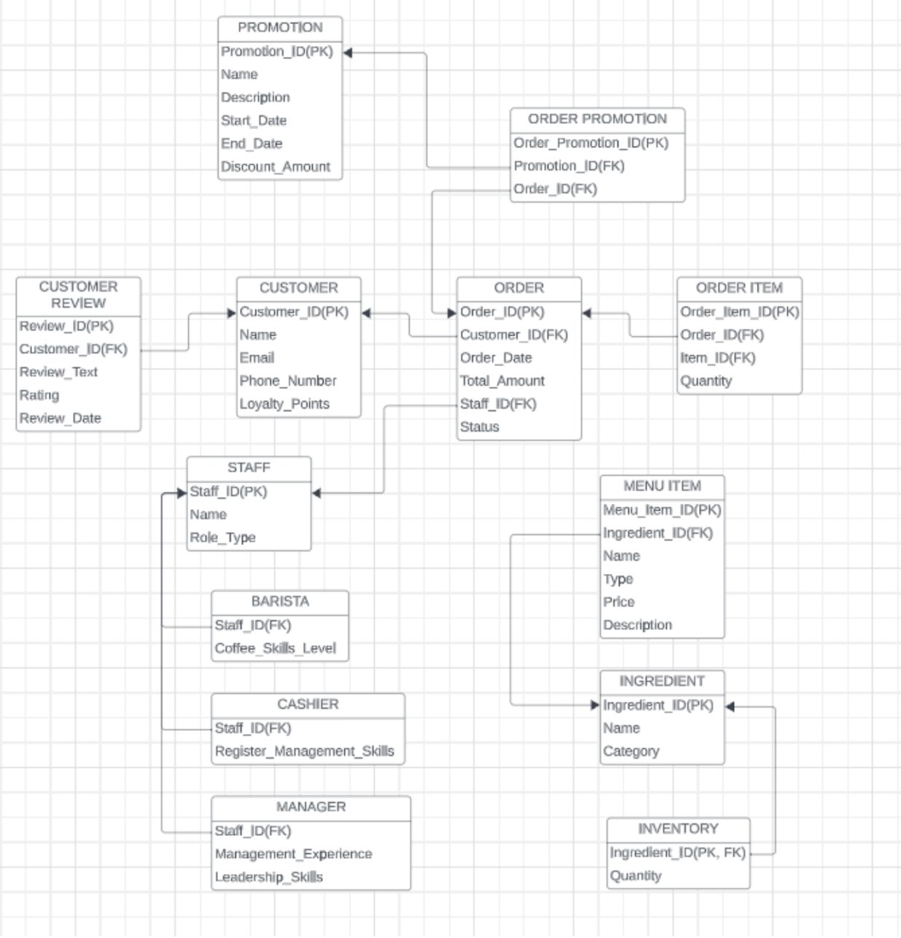

The original entity, "Ingredients_Inventory," which combined both "Ingredients" and "Inventory" information, underwent a decomposition process resulting in the creation of two distinct entities. This separation, even though the initial structure was normalized, contributes to further normalization by eliminating redundancy and segregating specific pieces of information into their respective dedicated tables.

# 

# Database Implementation

## 3.1 DDL SQL Code:

**Creating** entities (columns) in the table:

CREATE TABLE Customer (

Customer_ID INT PRIMARY KEY,

Name VARCHAR(255),

Email VARCHAR(255),

Phone_Number VARCHAR(20),

Loyalty_Points INT

);

CREATE TABLE Order (

Order_ID INT PRIMARY KEY,

Customer_ID INT,

Order_Date DATE,

Total_Amount DECIMAL(10, 2),

Staff_ID INT,

Status VARCHAR(255),

FOREIGN KEY (Customer_ID) REFERENCES Customer(Customer_ID),

FOREIGN KEY (Staff_ID) REFERENCES Staff(Staff_ID)

);

CREATE TABLE Order_Item (

Order_Item_ID INT PRIMARY KEY,

Order_ID INT,

Item_ID INT,

Quantity INT,

FOREIGN KEY (Order_ID) REFERENCES Order(Order_ID)

-- The Item_ID would be a foreign key to a Menu_Item table, for example.

);

CREATE TABLE Menu_Item (

Menu_Item_ID INT PRIMARY KEY,

Ingredient_ID INT,

Name VARCHAR(255),

Type VARCHAR(255),

Price DECIMAL(10, 2),

Description TEXT,

FOREIGN KEY (Ingredient_ID) REFERENCES Ingredient(Ingredient_ID)

);

CREATE TABLE Order_Promotion (

Order_Promotion_ID INT PRIMARY KEY,

Order_ID INT,

Promotion_ID INT,

FOREIGN KEY (Order_ID) REFERENCES Order(Order_ID),

FOREIGN KEY (Promotion_ID) REFERENCES Promotion(Promotion_ID)

);

CREATE TABLE Promotion (

Promotion_ID INT PRIMARY KEY,

Name VARCHAR(255),

Description TEXT,

Start_Date DATE,

End_Date DATE,

Discount_Amount DECIMAL(10, 2)

);

CREATE TABLE Staff (

Staff_ID INT PRIMARY KEY,

Name VARCHAR(255),

Role_Type VARCHAR(255),

Coffee_Skills_Level INT NULL,

Register_Management_Skills INT NULL,

Management_Experience INT NULL,

Leadership_Skills INT NULL

);

CREATE TABLE Ingredient (

Ingredient_ID INT PRIMARY KEY,

Name VARCHAR(255),

Category VARCHAR(255)

);

CREATE TABLE Inventory (

Ingredient_ID INT,

Quantity INT,

FOREIGN KEY (Ingredient_ID) REFERENCES Ingredient(Ingredient_ID)

);

CREATE TABLE Customer_Review (

Review_ID INT PRIMARY KEY,

Customer_ID INT,

Review_Text TEXT,

Rating DECIMAL(2, 1),

Review_Date DATE,

FOREIGN KEY (Customer_ID) REFERENCES Customer(Customer_ID)

);

**Inserting** dummy values in the table, the examples below are merely representative and do not encompass the entire database:

INSERT INTO Customer (Customer_ID, Name, Email, Phone_Number, Loyalty_Points)

VALUES

(1, 'John Doe', 'john.doe@example.com', '555-1234', 100),

(2, 'Jane Smith', 'jane.smith@example.com', '555-5678', 150),

(3, 'Bob Johnson', 'bob.johnson@example.com', '555-9876', 50),

(4, 'Alice Williams', 'alice.williams@example.com', '555-4321', 200),

(5, 'Charlie Brown', 'charlie.brown@example.com', '555-8765', 75),

(6, 'Emma Davis', 'emma.davis@example.com', '555-2345', 120),

(7, 'Michael Wilson', 'michael.wilson@example.com', '555-8761', 90),

(8, 'Sophia Taylor', 'sophia.taylor@example.com', '555-3456', 180),

(9, 'Daniel Miller', 'daniel.miller@example.com', '555-6543', 30),

(10, 'Olivia Anderson', 'olivia.anderson@example.com', '555-7890', 160),

(11, 'William White', 'william.white@example.com', '555-8901', 70)

INSERT INTO Order (Order_ID, Customer_ID, Order_Date, Total_Amount, Staff_ID, Status)

VALUES

(101, 1, '2023-01-05', 150.00, 5, 'Completed'),

(102, 2, '2023-01-15', 200.50, 12, 'Pending'),

(103, 3, '2023-02-01', 75.25, 17, 'Completed'),

(104, 4, '2023-02-15', 300.00, 22, 'Pending'),

(105, 5, '2023-03-01', 120.75, 28, 'Completed'),

(106, 6, '2023-03-15', 180.50, 11, 'Pending'),

(107, 7, '2023-04-01', 90.20, 4, 'Completed'),

(108, 8, '2023-04-15', 250.00, 25, 'Pending')

INSERT INTO Menu_Item (Menu_Item_ID, Ingredient_ID, Name, Type, Price, Description)

VALUES

(1, 201, 'Espresso', 'Coffee', 2.99, 'A strong black coffee made by forcing steam through ground coffee beans.'),

(2, 202, 'Cappuccino', 'Coffee', 3.49, 'Espresso mixed with equal parts of steamed milk and milk foam.'),

(3, 203, 'Latte', 'Coffee', 3.99, 'Espresso mixed with a large amount of steamed milk and a small amount of milk foam.'),

(4, 204, 'Americano', 'Coffee', 2.79, 'A diluted espresso with hot water, giving it a similar strength to traditional drip coffee.'),

(5, 205, 'Macchiato', 'Coffee', 3.29, 'Espresso with a small amount of milk or foam on top.')

INSERT INTO Ingredient (Ingredient_ID, Name, Category)

VALUES

(201, 'Coffee Beans', 'Coffee'),

(202, 'Milk', 'Dairy'),

(203, 'Steamed Milk', 'Dairy'),

(204, 'Hot Water', 'Water'),

(205, 'Foamed Milk', 'Dairy'),

(206, 'Chocolate Syrup', 'Syrup'),

(207, 'Iced Coffee Concentrate', 'Coffee'),

(208, 'Chai Tea Concentrate', 'Tea'),

(209, 'Green Tea Leaves', 'Tea')

INSERT INTO Inventory (Ingredient_ID, Quantity)

VALUES

(201, 150),

(202, 300),

(203, 200),

(204, 100),

(205, 120),

(206, 80),

(207, 250),

(208, 100),

(209, 30),

(210, 40)

INSERT INTO Customer_Review (Review_ID, Customer_ID, Review_Text, Rating, Review_Date)

VALUES

(101, 1, 'Great service and delicious coffee!', 4.5, '2023-01-10'),

(102, 2, 'The cappuccino was fantastic!', 4.0, '2023-03-12'),

(103, 3, 'Loved the atmosphere and friendly staff.', 4.2, '2023-04-15'),

(104, 4, 'Good place to hang out with friends.', 3.8, '2023-06-18'),

(105, 5, 'The iced coffee hit the spot!', 4.5, '2023-07-20'),

(106, 6, 'Cozy ambiance and great selection of pastries.', 4.2, '2023-08-25'),

(107, 7, 'Quick service and good quality coffee.', 4.0, '2023-09-28'),

(108, 8, 'Enjoyed the chai latte, but a bit too sweet.', 3.5, '2023-10-01')

INSERT INTO Staff (Staff_ID, Name, Role_Type, Coffee_Skills_Level, Register_Management_Skills, Management_Experience, Leadership_Skills)

VALUES

(1, 'Alice', 'Barista', 3, NULL, NULL, NULL),

(2, 'Bob', 'Barista', 4, NULL, NULL, NULL),

(3, 'Charlie', 'Barista', 2, NULL, NULL, NULL),

(4, 'David', 'Barista', 4, NULL, NULL, NULL),

(5, 'Emma', 'Barista', 3, NULL, NULL, NULL),

(6, 'Frank', 'Barista', 2, NULL, NULL, NULL),

(7, 'Grace', 'Manager', NULL, NULL, 4, 5),

(8, 'Henry', 'Manager', NULL, NULL, 5, 4),

(9, 'Ivy', 'Manager', NULL, NULL, 3, 3),

(10, 'Jack', 'Cashier', NULL, 2, NULL, NULL),

(11, 'Kelly', 'Cashier', NULL, 1, NULL, NULL)

INSERT INTO Promotion (Promotion_ID, Name, Description, Start_Date, End_Date, Discount_Amount)

VALUES

(1, 'New Year Special', 'Kickstart the year with our special promotion!', '2023-01-01', '2023-01-15', 10.00),

(2, 'Spring Fling', 'Celebrate the season with fresh flavors and savings!', '2023-03-15', '2023-03-31', 12.50),

(3, 'Summer Sizzle', 'Beat the heat with cool savings on your favorite items!', '2023-06-01', '2023-06-30', 15.00)

INSERT INTO Order_Promotion (Order_Promotion_ID, Order_ID, Promotion_ID)

VALUES

(1, 101, 1),

(2, 102, 2),

(3, 103, 3),

(4, 104, 4),

(5, 105, 5),

(6, 106, 6),

(7, 107, 7),

(8, 108, 8),

(9, 109, 9)

INSERT INTO Order_Item (Order_Item_ID, Order_ID, Item_ID, Quantity)

VALUES

(1, 101, 1, 2),

(2, 102, 5, 1),

(3, 103, 3, 3),

(4, 104, 7, 1),

(5, 105, 2, 2),

(6, 106, 4, 1),

(7, 107, 6, 3),

(8, 108, 1, 1),

(9, 109, 8, 2)

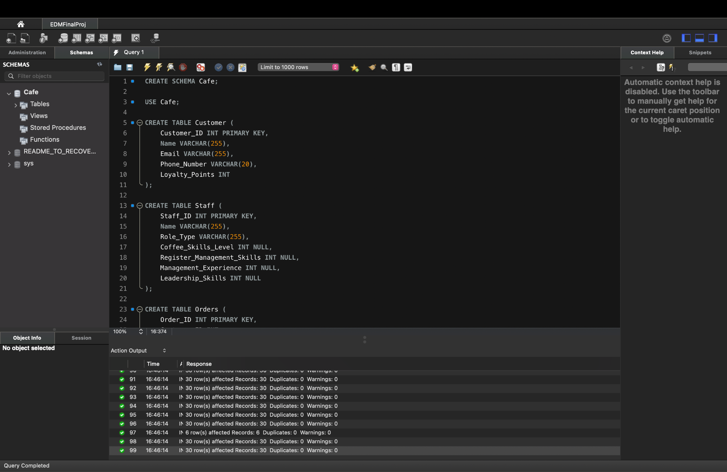

## 3.2 SQL Queries Examples of the Database

### 3.2.1 Top 5 Customers with the Highest Loyalty Points:

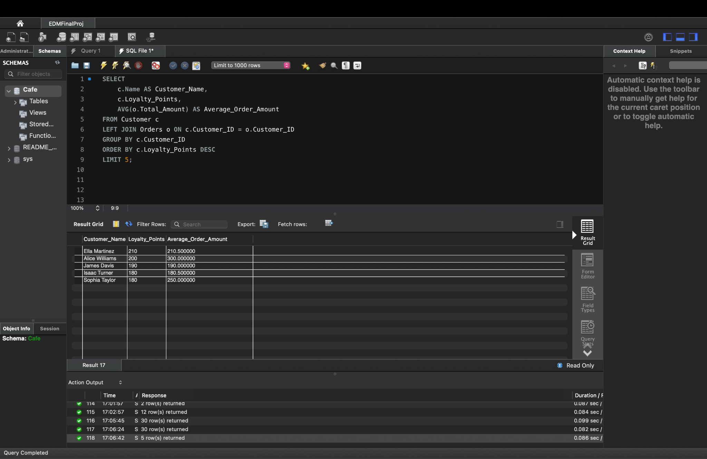

### 3.2.2 Top 10 Selling Menu Items

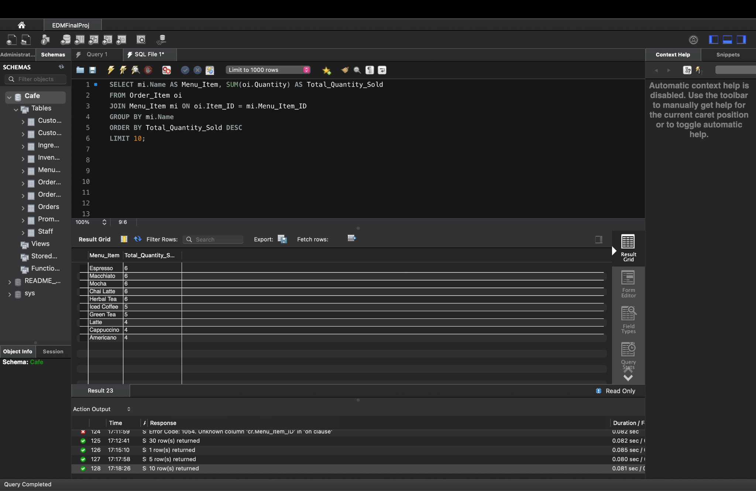

### 3.2.3 Top 3 Baristas of the year based on Coffee Skills:

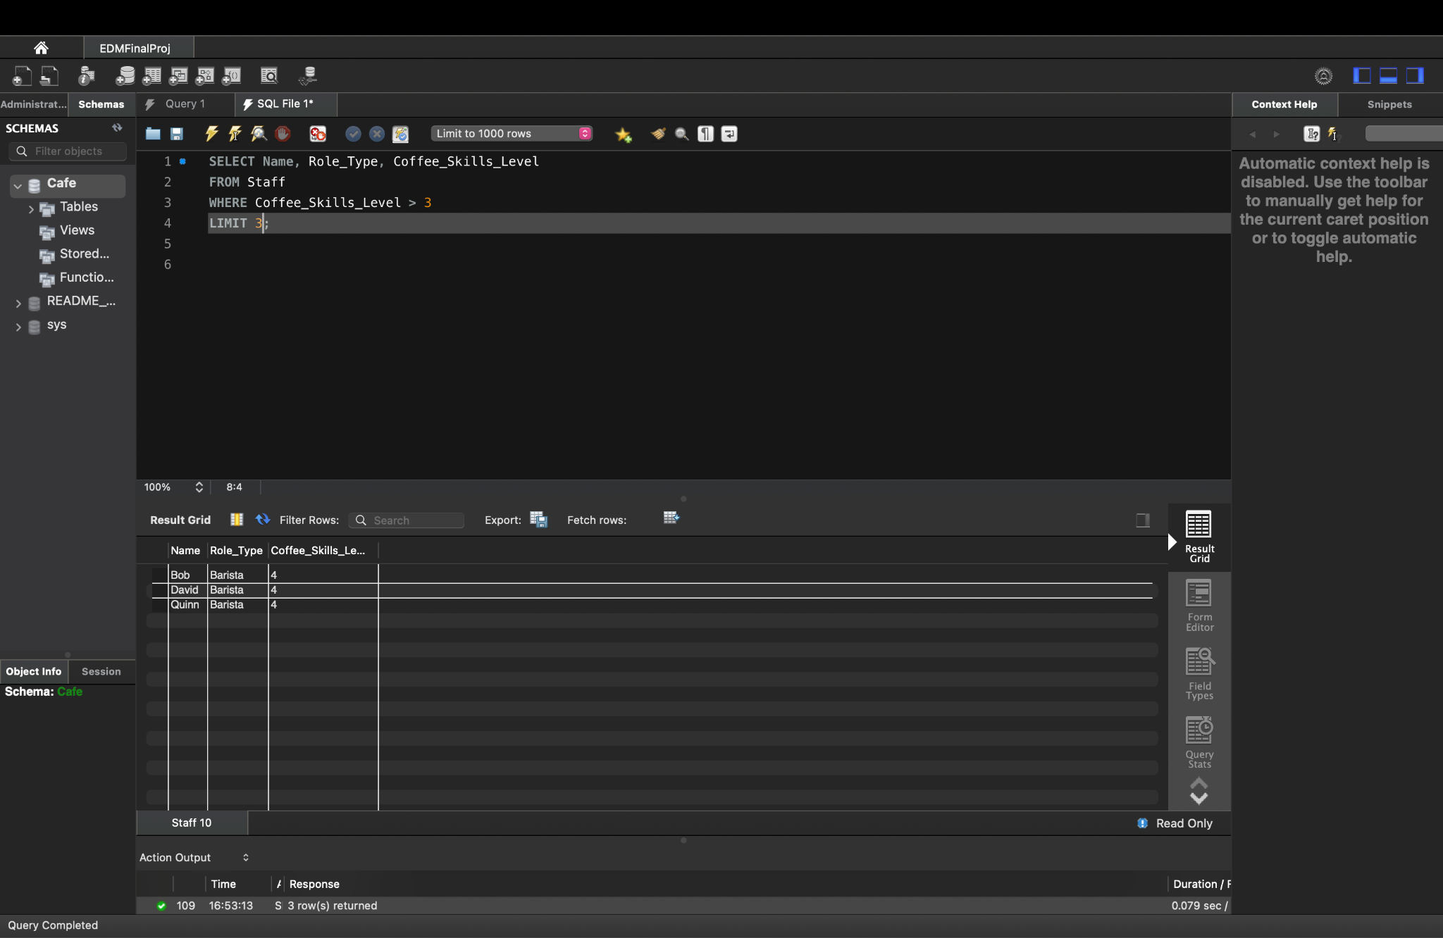

### 3.2.4 Promotional Analysis - The total revenue earned during each promotion:

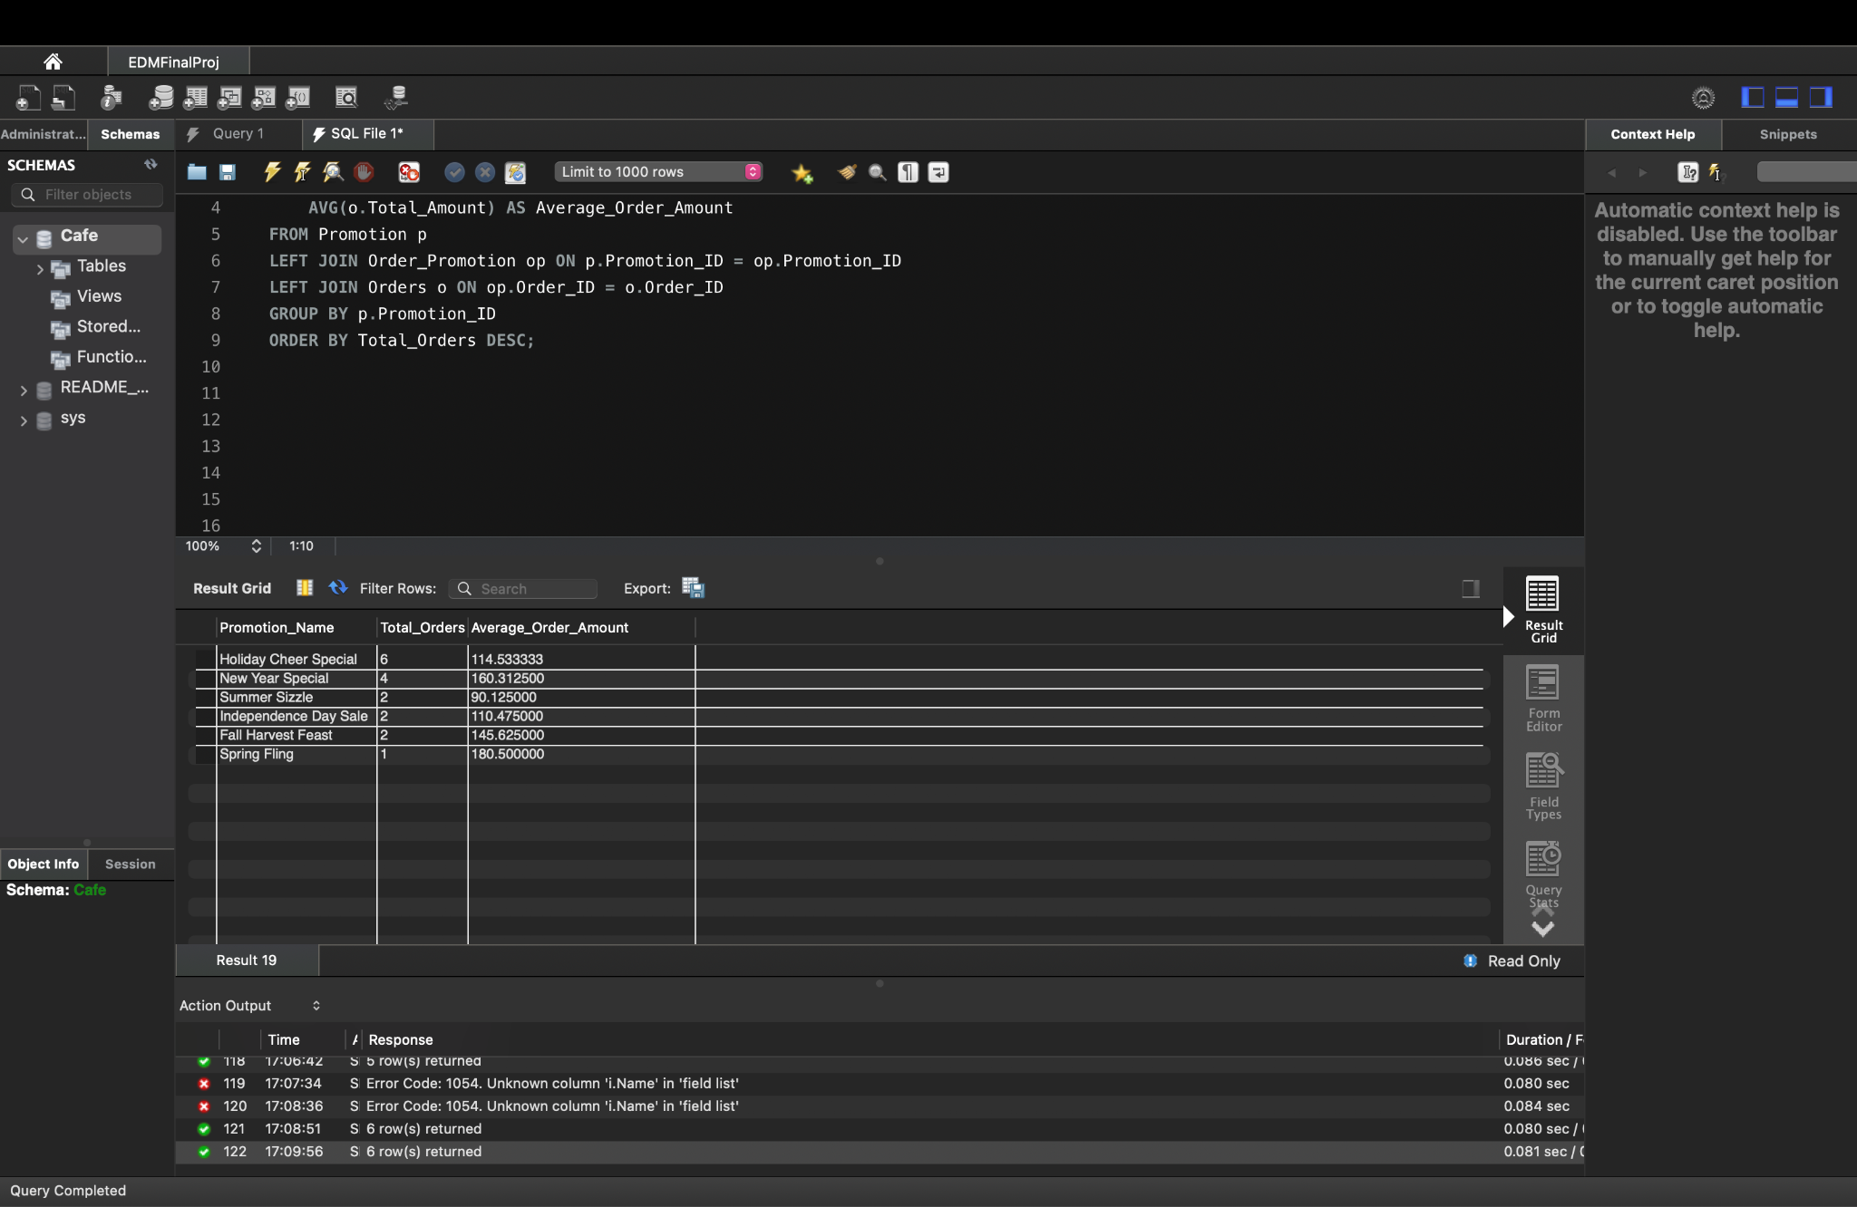

### 3.2.5 Items that are out of stock or have low inventory(below 50):

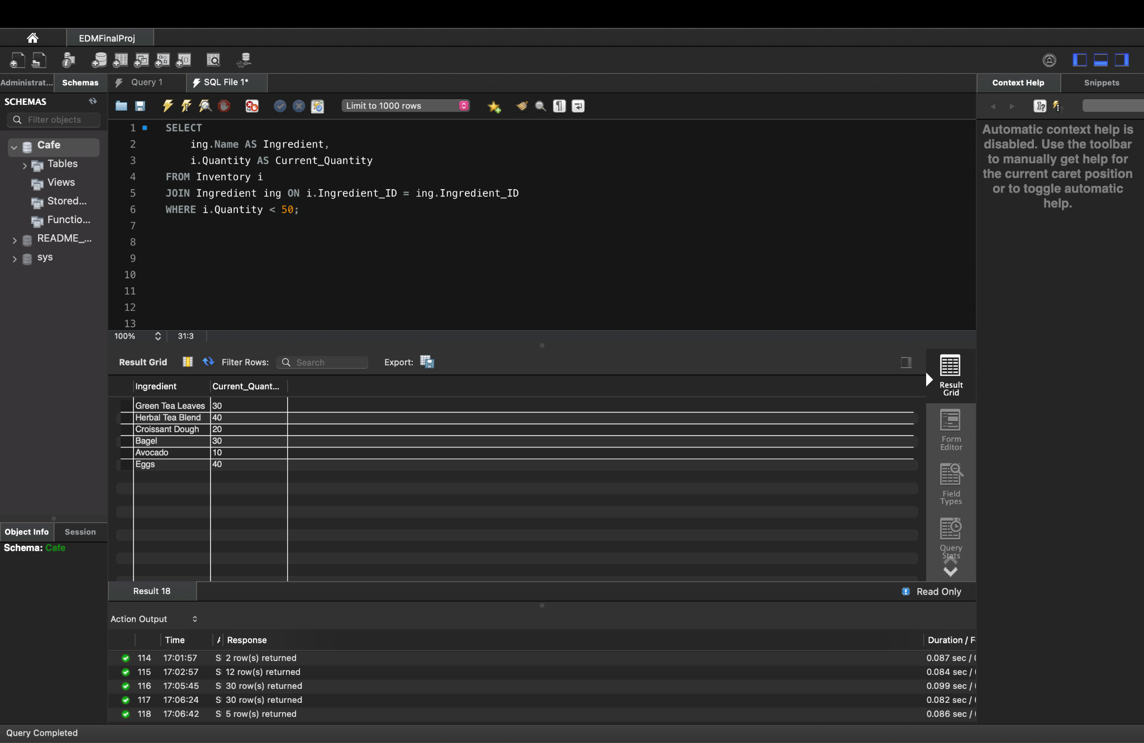

### 3.2.6 Total revenue for each month:

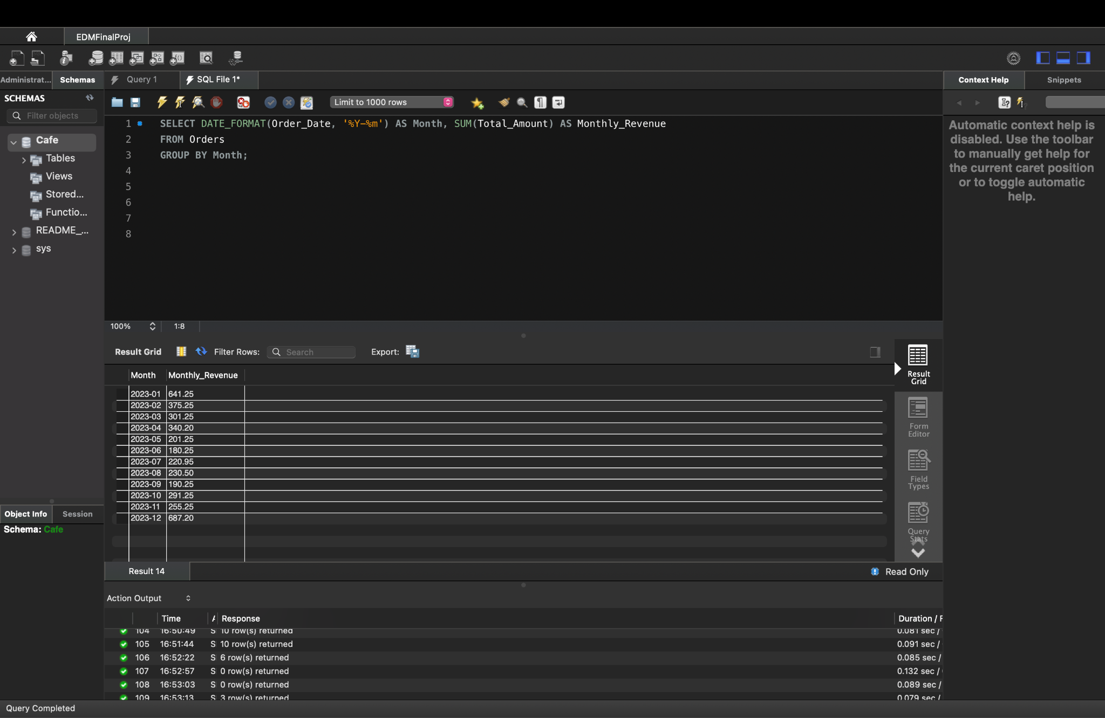

### 3.2.7 Checking if a particular date falls under a promotion during the year:

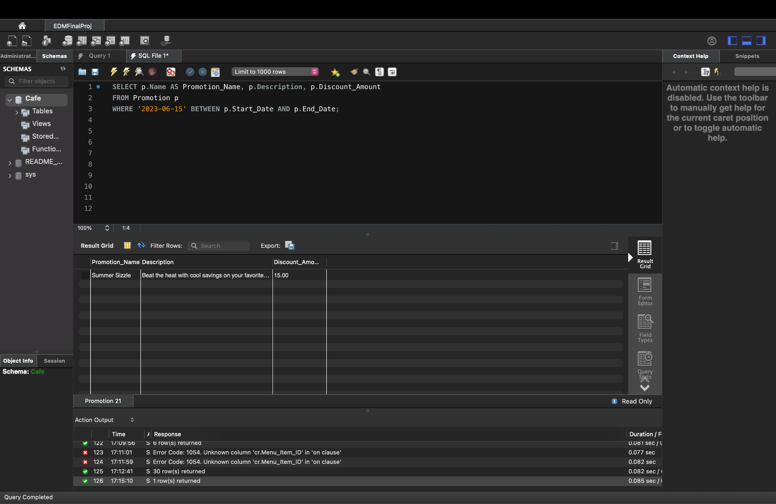

## 3.3 TRIGGERS

1. **update_loyalty_points_insert**

The update_loyalty_points_insert trigger is a crucial component of the database architecture, designed to enhance customer loyalty by automatically updating loyalty points based on new order insertions. Activated after an order is inserted into the orders table, this trigger calculates loyalty points by considering the total amount spent on the order. The order_amount variable captures the monetary value of the order, and the loyalty points are calculated using a straightforward formula, allocating one point for every $10 spent. The trigger then updates the customer's loyalty points in the customers table by adding the calculated points to the existing total. This ensures that as customers make purchases, their loyalty points are dynamically adjusted, providing an incentive for repeat business and fostering a positive customer relationship. The trigger's streamlined logic, coupled with its seamless integration into the order insertion process, contributes to a responsive and efficient loyalty program within the database.

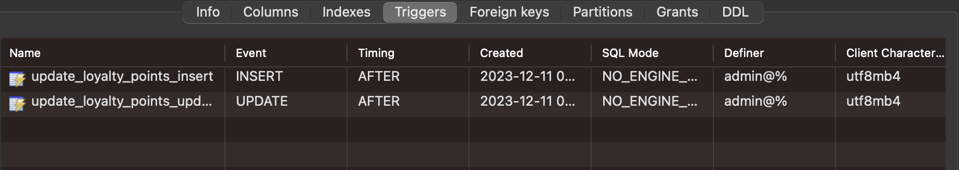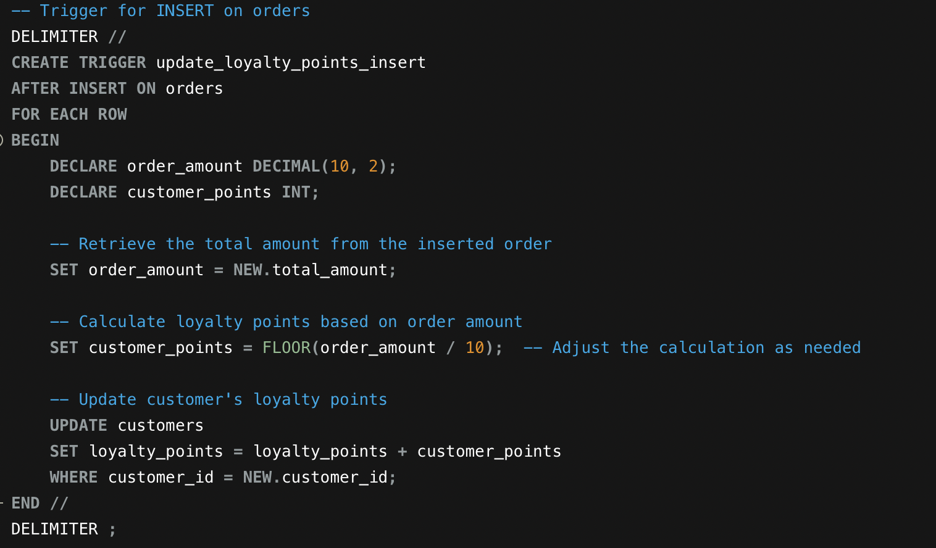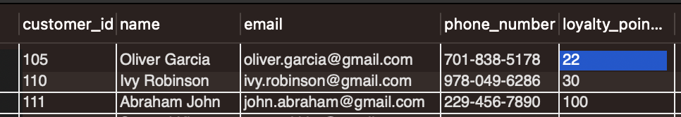

The loyalty points for Oliver Garcia were automatically adjusted from 20 to 22 through the utilization of this trigger. Consequently, each time Oliver Garcia places an order, the loyalty points associated with this customer in the 'customers' table undergo automatic updates, ensuring a seamless and effortless management of loyalty rewards for the specific customer.

# 4. App-Database Interaction

In the chapter on app-database interaction for our cafe database management project, we will be exploring the integration of a simple application with a comprehensive dashboard to facilitate the required analytics derived from our database.

As we delve into the subsequent sections, we will illustrate the step-by-step process of developing this application, detailing how each segment of the code contributes to the overall functionality of the analytics dashboard. The custom analytics we have implemented are tailored to the unique demands of our cafe management, providing a tailored perspective on operational performance, customer engagement, inventory management, and promotional effectiveness.

## 4.1 Top 10 Customers by Loyalty Points

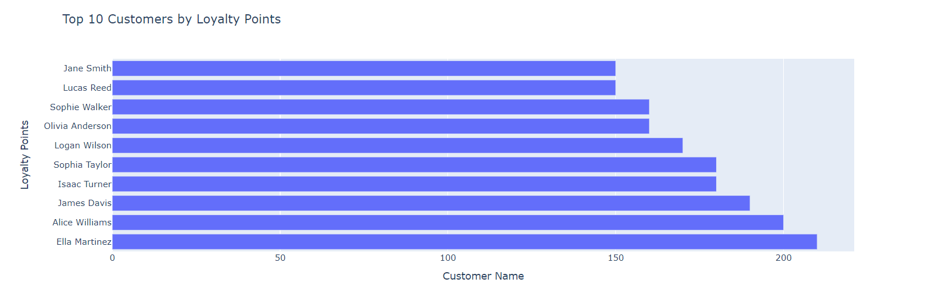

Our database analysis includes an examination of the loyalty points accrued by customers, which is a significant indicator of customer engagement and retention. The chart titled "Top 10 Customers by Loyalty Points" presents a clear and concise visualization of this data, identifying the customers who are the most engaged with our cafe's loyalty program.

The horizontal bar graph ranks the top ten customers according to the loyalty points they have earned. Jane Smith leads the pack with the highest number of points, indicating her frequent patronage and engagement with our services. Following her are Lucas Reed, Sophie Walker, and others, who form the cohort of our most loyal customers.

## 4.2 Total Order Amount by Staff

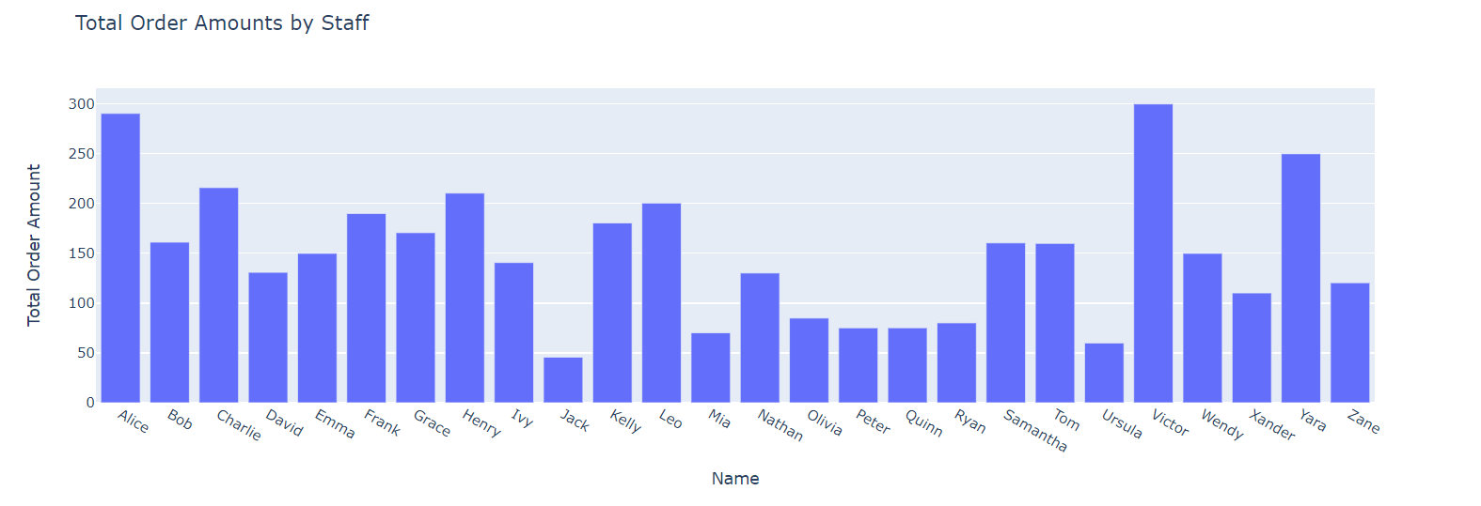

The bar chart "Total Order Amounts by Staff" illustrates the total sales generated by each staff member at our cafe. The chart provides a straightforward comparison of staff performance in terms of sales, which is a valuable metric for assessing productivity and customer service efficiency.

Alice stands out with the highest total order amount, suggesting that she is either handling more transactions or selling higher-priced items. On the other end, certain staff members, such as Jack and Quinn, have lower total sales, which could be due to a variety of factors such as fewer shifts, lower traffic during their shifts, or a focus on tasks that involve less direct sales activity.

The total order amount is a crucial indicator from our database design, which captures and relates staff activity to sales data. This metric is integral to our business operations as it helps identify training needs, reallocate staff based on busy periods, or incentivize high performance. It also assists in making informed decisions regarding staff scheduling, inventory management, and the overall financial health of the cafe.

## 4.3 Monthly Revenue by Staff

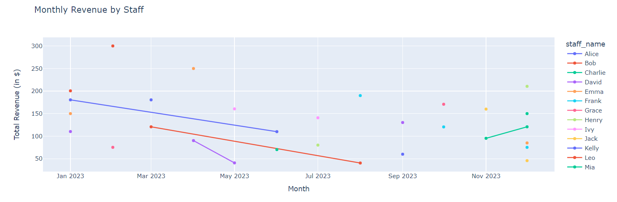

The line chart titled "Monthly Revenue by Staff" depicts the revenue generated by individual staff members each month over the course of the year 2023. Each line represents a staff member's sales performance over time, providing an easy-to-understand visual of trends and fluctuations in revenue contribution.

From a database design perspective, this chart illustrates the dynamic capability of our system to track and report on time-series data, specifically the revenue generated by staff over time. The database is designed to associate each transaction with the staff member responsible, allowing for detailed reporting and analysis of sales performance.

## 4.4 Staff Counts by Role Type

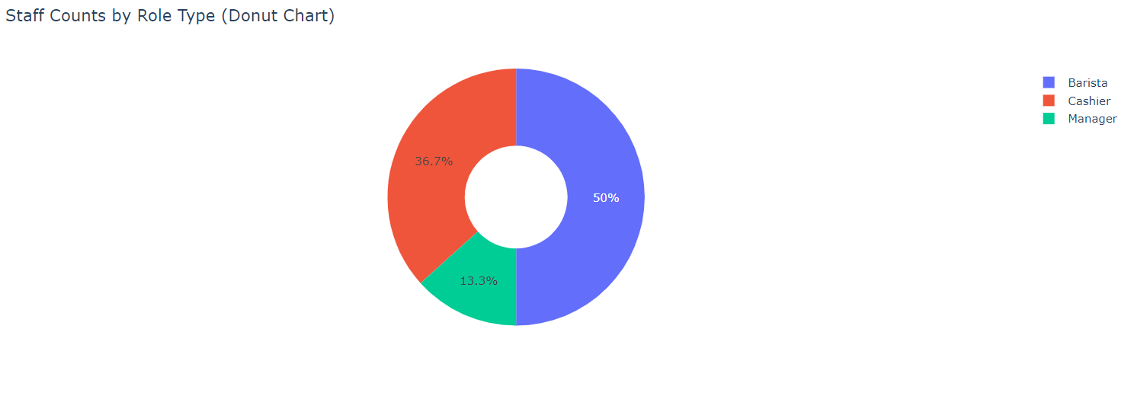

The donut chart titled "Staff Counts by Role Type" provides a visual breakdown of the composition of our cafe's workforce according to their roles. The chart indicates that half of the staff are Baristas, which aligns with the primary offering of a cafe – serving coffee. Cashiers makeup 36.7% of the staff, reflecting the need for efficient transaction handling and customer service at the point of sale. Managers are the smallest group at 13.3%, which is typical for an organizational structure where fewer managers are required to oversee operations.

## 4.5 Customer Loyalty Points Distribution

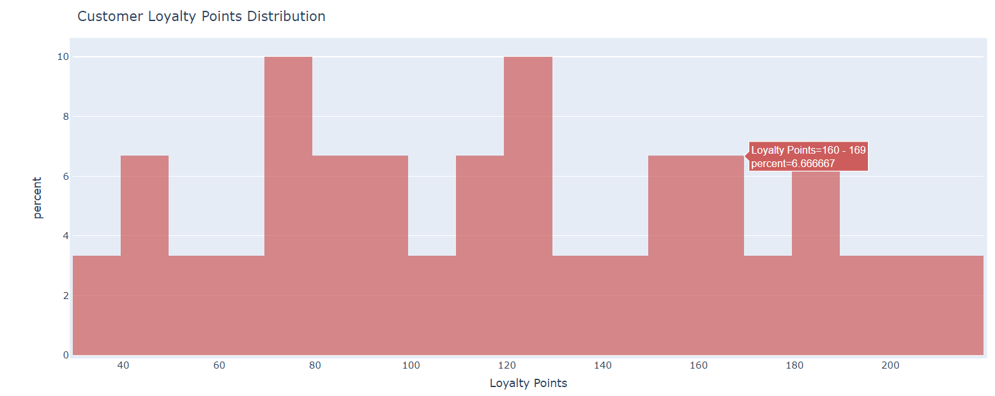

The histogram titled "Customer Loyalty Points Distribution" provides an analysis of the spread of loyalty points among our customer base. The x-axis represents the loyalty points range, while the y-axis shows the percentage of customers falling into each loyalty point category.

The distribution indicates a varied spread of loyalty points, with a notable percentage of customers accumulating points in the 160-169 range. This peak suggests a successful engagement of customers within this range of loyalty points accrual. Conversely, the lower and higher ends of the points spectrum show fewer customers, which may indicate opportunities to enhance our loyalty program to encourage more consistent engagement across all points levels.

## 4.6 Inventory Status

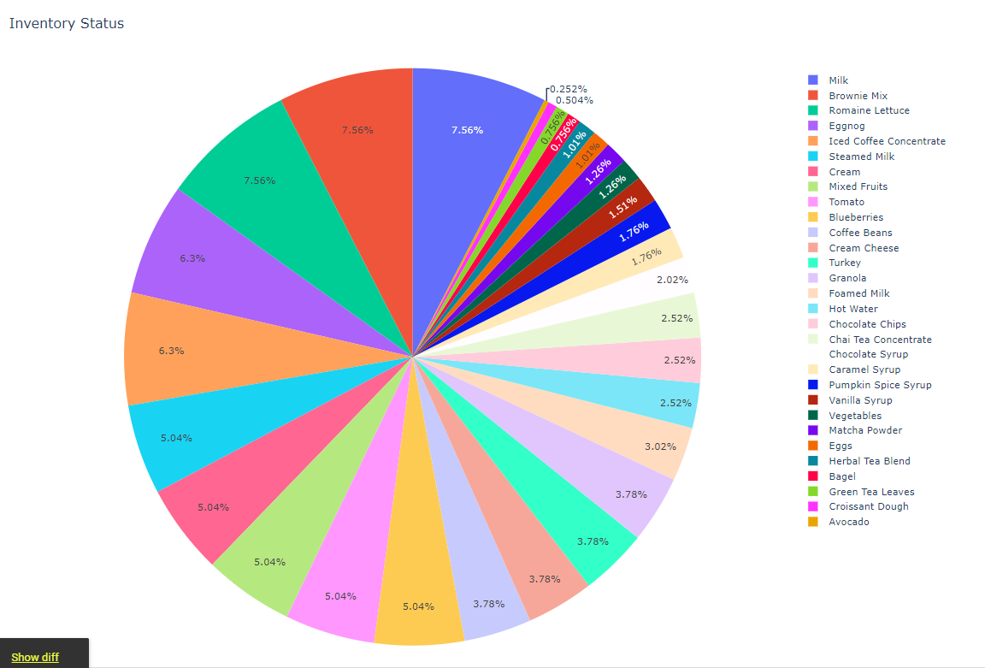

Effective inventory management is crucial for maintaining the balance between demand and supply, ensuring that popular items are always in stock while preventing overstocking, which could lead to waste, especially with perishable goods. The chart aids in quickly identifying which items are most abundant and which may require reordering, supporting the operational efficiency of the cafe.

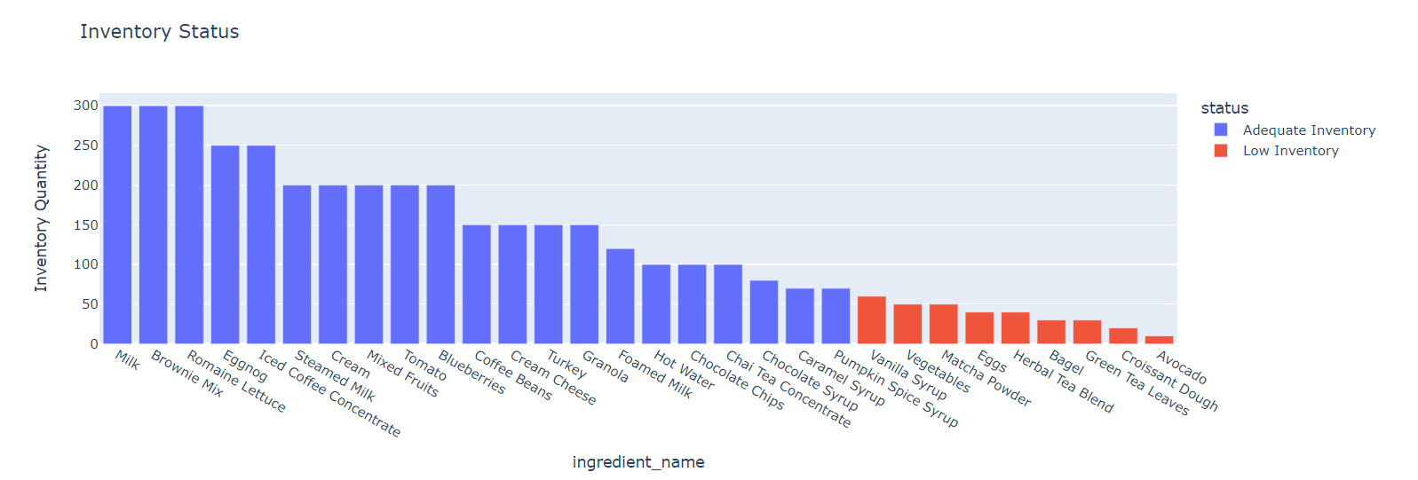

The bar chart titled "Inventory Status" displays the current stock levels of various ingredients used in our cafe. The chart uses two colors to differentiate between 'Adequate Inventory' (blue) and 'Low Inventory' (red), providing a clear visual cue on the status of each item.

From the chart, we can discern that essential items like Milk, Brownie Mix, and Romaine Lettuce are well-stocked, indicating that the cafe is prepared to meet customer demand for products involving these ingredients. Conversely, items such as Avocado, Croissant Dough, and Green Tea Leaves which are less than 70 (threshold value) are in low supply, signaling the need for imminent restocking to avoid potential disruptions in menu offerings.

This visualization is an extension of our database design, which likely includes an inventory management system with a table that tracks the quantity of each ingredient. This system enables real-time inventory tracking and supports efficient ordering processes. By setting threshold levels, the system can automatically categorize inventory levels as adequate or low, as depicted in the chart.

## 4.7 Monthly RevenueUploaded image

The line graph titled "Monthly Revenue" depicts the revenue trend of our cafe over the span of 2023. The graph shows significant fluctuations in monthly revenue, with the highest peak towards the end of the year in November.

The data represented in the graph is indicative of the kind of financial reporting that can be generated from our database, which captures detailed transactional information. Our database design, with its comprehensive order and sales tracking, allows for this kind of temporal financial analysis, providing critical insights into business performance and seasonal trends.

4.9 Monthly Sales Comparison with Promotions

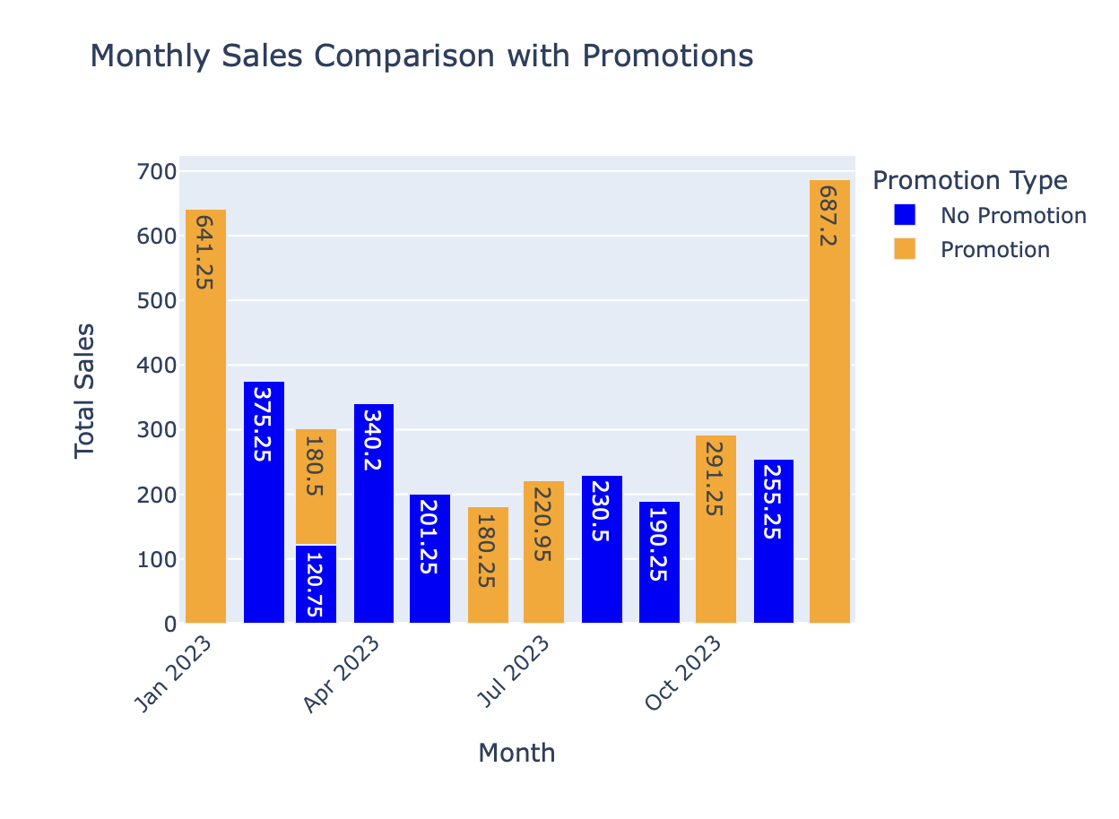

The bar chart "Monthly Sales Comparison with Promotions" illustrates the impact of promotional activities on monthly sales throughout various months in 2023. The dual-colored bars represent the total sales, with blue indicating sales without promotions and orange signifying sales with promotions.

The data indicates that careful planning and execution of promotional strategies can lead to substantial increases in revenue. These insights are crucial for planning future marketing initiatives, optimizing the timing and nature of promotions to maximize profitability and customer engagement.

## 4.8 Promotion Impact on Sales

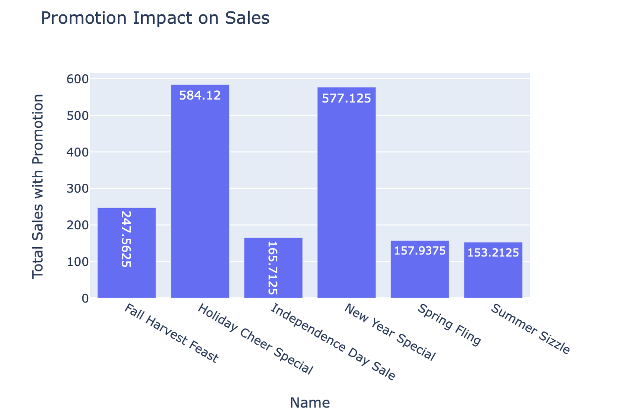

The bar graph titled "Promotion Impact on Sales" provides a clear depiction of the sales figures associated with different promotional events throughout various seasons. Each bar represents the total sales achieved during a specific promotional campaign.

From a database design perspective, these results would be derived from joining sales data with promotional campaign records. This design allows for the analysis of sales performance in direct correlation with promotional activities.

## 4.9. Total Quantity Sold by Menu Item

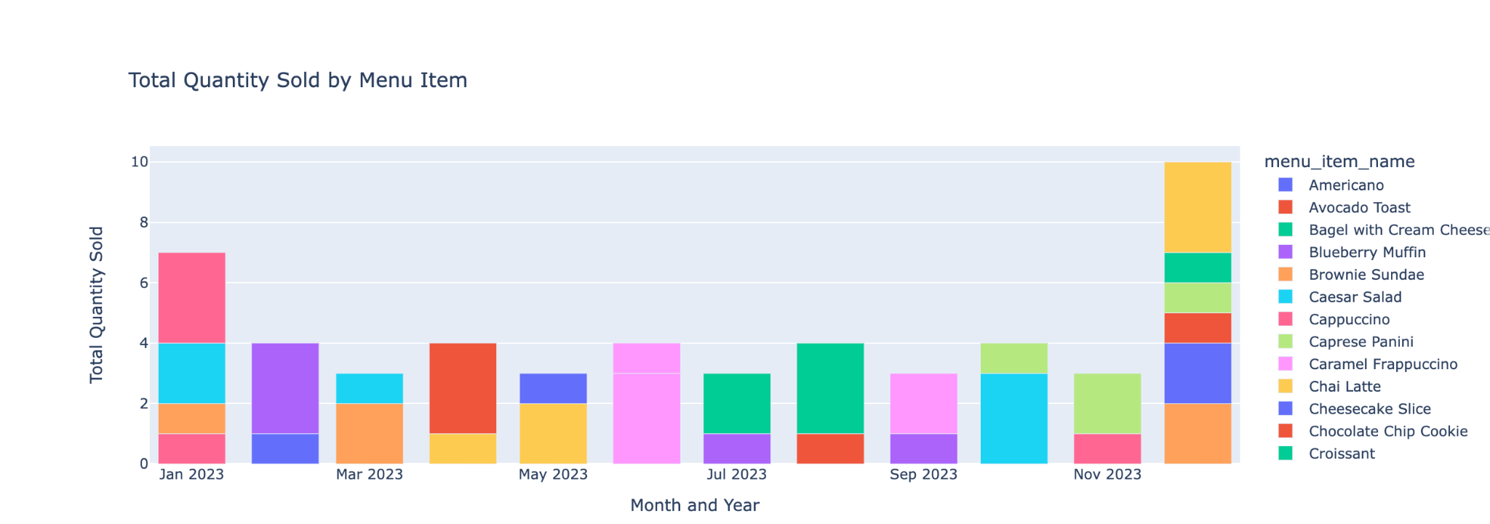

This stacked bar chart shows the different type of menu items that were ordered in each month.

## 4.10 Distribution of Menu Item by Category

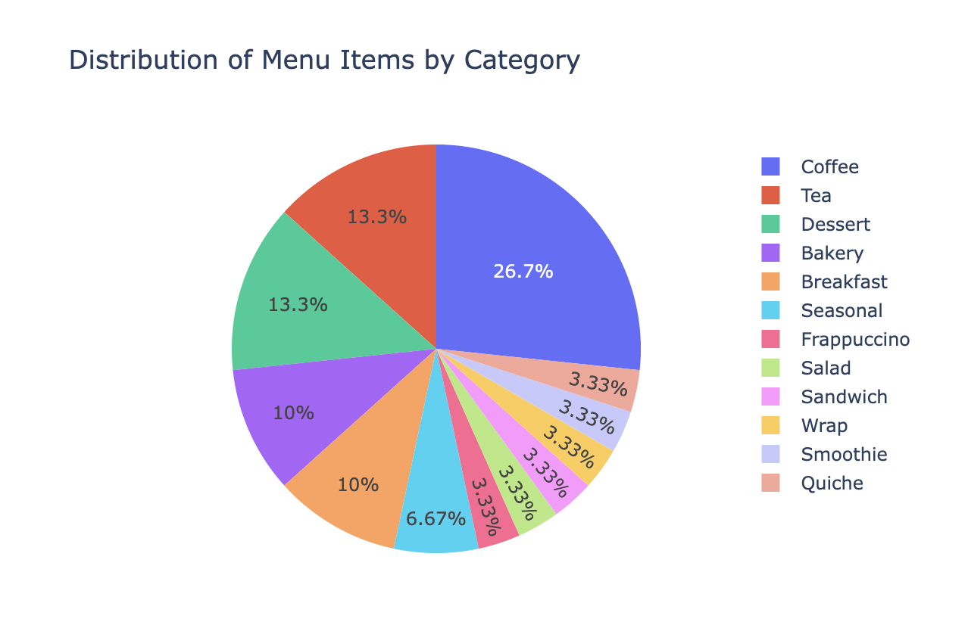

This pie chart shows the distribution of various types of categories that are available in this cafe in which the coffee has the highest percentage around 26.7.

## 4.11 Average Customer Rating Over Time

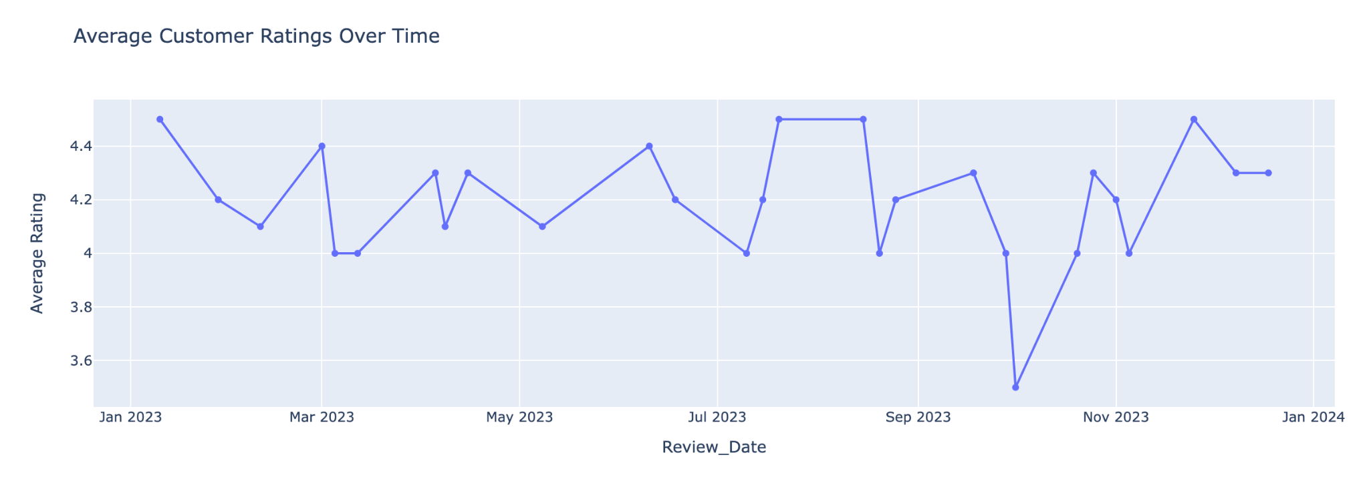

This lie chart shows the ratings given by the customers throughout the year. We see a dip between September and November of 2023 and a rise during November 2023.

# 5. Conclusion

In conclusion, our project has successfully demonstrated the robustness and versatility of a well-structured database in managing and streamlining the operations of a cafe. Throughout the course of this project, from database and table design to the detailed analytics performed, we have illustrated the integral role that a comprehensive database system plays in the hospitality industry.

Our database design was meticulously crafted to encompass all facets of cafe management, including customer data, order processing, inventory management, and staff allocation. The table structures were optimized for efficiency, ensuring that queries could be executed swiftly and that the database could scale seamlessly with the growth of the business.

The analytical portion of our report provided deep insights into customer loyalty, staff performance, and inventory status—each a vital component of the cafe's success. Our analyses revealed patterns and trends that are invaluable for making informed decisions. For instance, understanding customer loyalty points distribution helps tailor marketing efforts, while staff performance analysis ensures that we optimize labor allocation to enhance customer service. Inventory analyses prevent stockouts and overstocking, thereby reducing waste and ensuring the availability of fresh ingredients.

This project's findings emphasize the importance of data-driven decision-making. By leveraging the data collected through our database, we can make strategic choices that not only improve day-to-day operations but also enhance the customer experience, boost staff morale and performance, and ensure financial health and growth for the business.